SMT Ingleborough Trek (17/12/2017)  SPONSORSHIP FORM |  |  |  |  |  |  |  |  |  | 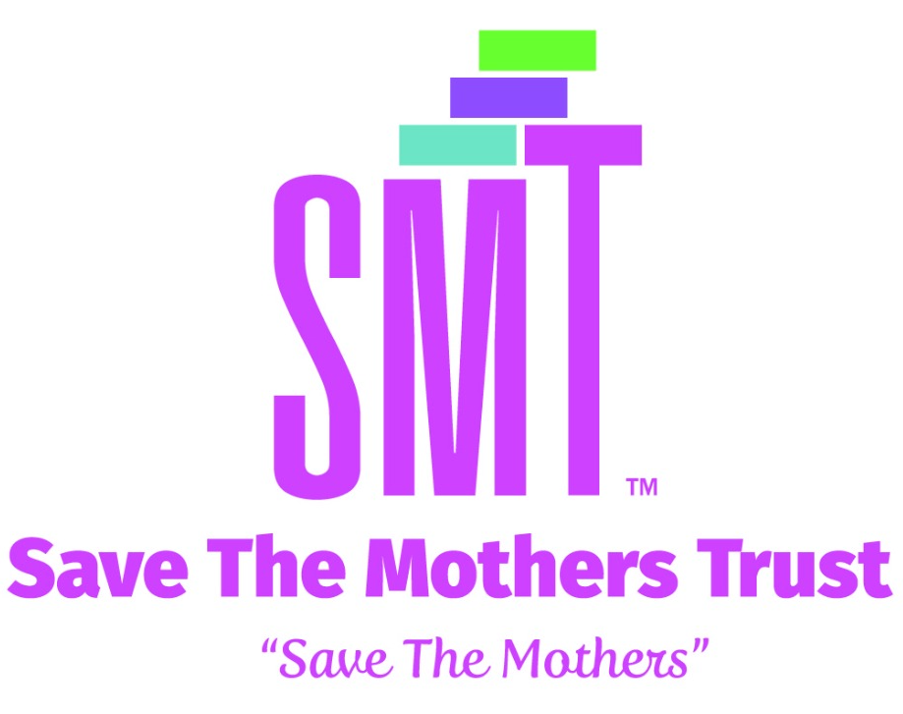
Name of Sponsor:

Event Date:

Details of Event:
Gift Aid -  what is it? | Using Gift Aid means that for every pound given, your charity will receive an extra 25p. from the Inland Revenue, helping each donation go further at no cost to the donor.  DECLARATION: We, who have given our names and addresses below and who have ticked the box entitled ‘Gift Aid (✓)’, want Save the Mothers Trust to reclaim tax on the donation detailed below. We understand that each of us must pay income tax or capital gains tax equal to the tax reclaimed by the charity on the donation.
* Gift Aid: | I would like my donation  to benefit from Gift Aid |  |  |  |  |  | Please detail your full name, home address and postcode and tick the box to state you have read the declaration above and would like the tax claimed back on your donation
* Full Name |  |  | * Home Address |  |  |  | * Postcode | * Gift Aid  (✓) |  |  |  |  | Amount pledged | Amount paid | Data Opt Out  (✓)
Thank you for your generous support  Please make cheques payable to:  Save the Mothers Trust |  |  |  |  |  |  |  | TOTAL DONATIONS RECEIVED
For Office  Use Only |  | Date money received  __________________ |  |  |  | Total amount of Gift Aid donations  £____________
Save The Mothers Trust will use your information for administration and analysis. We will not share your information with other companies or third parties. We may send you details of other goods and services which may be of interest to you. The information may be provided by letter, telephone or other reasonable means of communication. If you do not wish your details to be shared with carefully selected third parties, please tick the column headed ‘Data Opt Out ( √ )’ on this form.
SAVE THE MOTHERS TRUST |  |  |  |  | SM Complex, Beckside Lane, Bradford BD7 2JX  Tel: 01274 270043 E: info@smtrust.org.uk W: www.savethemothers.org.uk  Charity Registration No: 1104771

